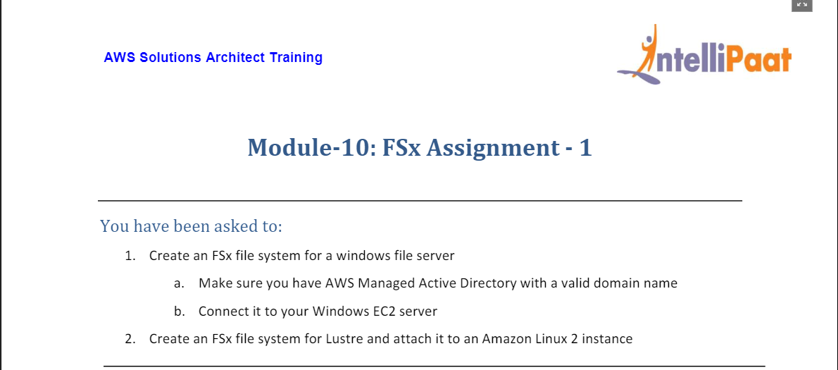

1. For this we first head to Directory Service as shown below:

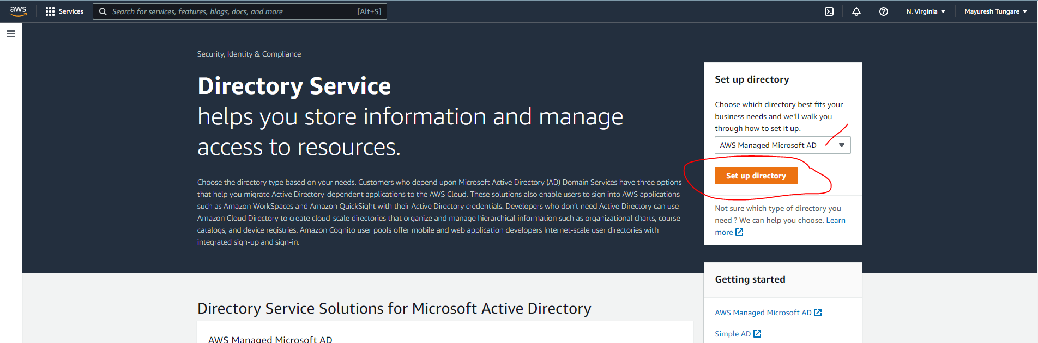

1. Next, we choose AWS Managed Microsoft AD

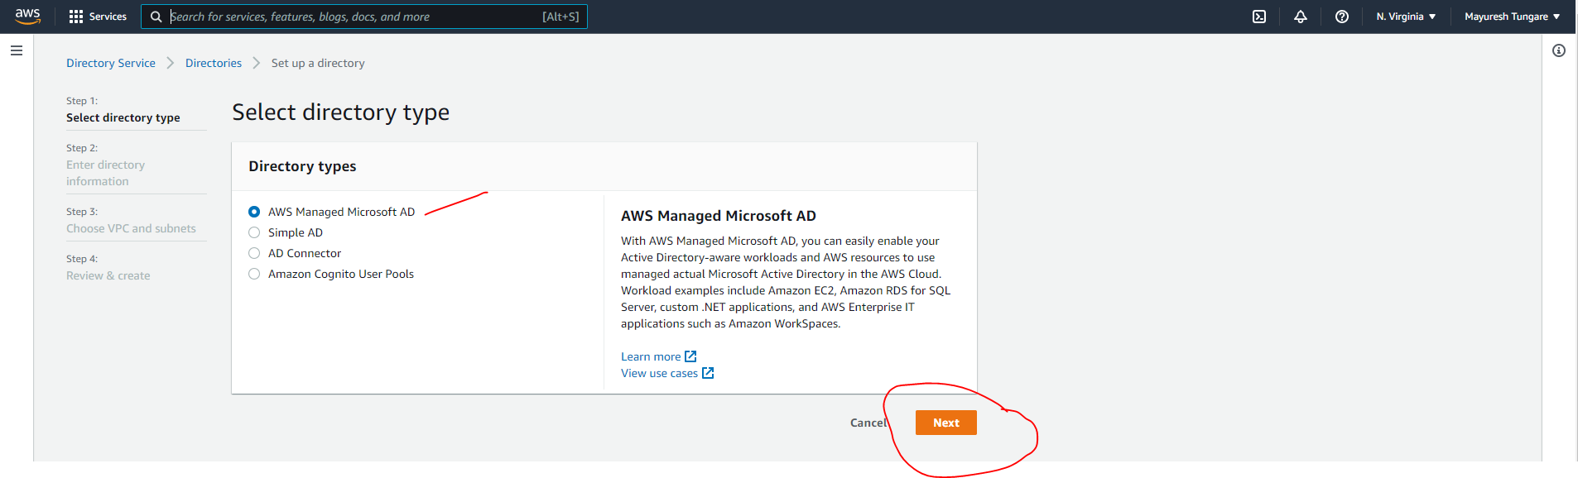

1. Fill in details as shown below:

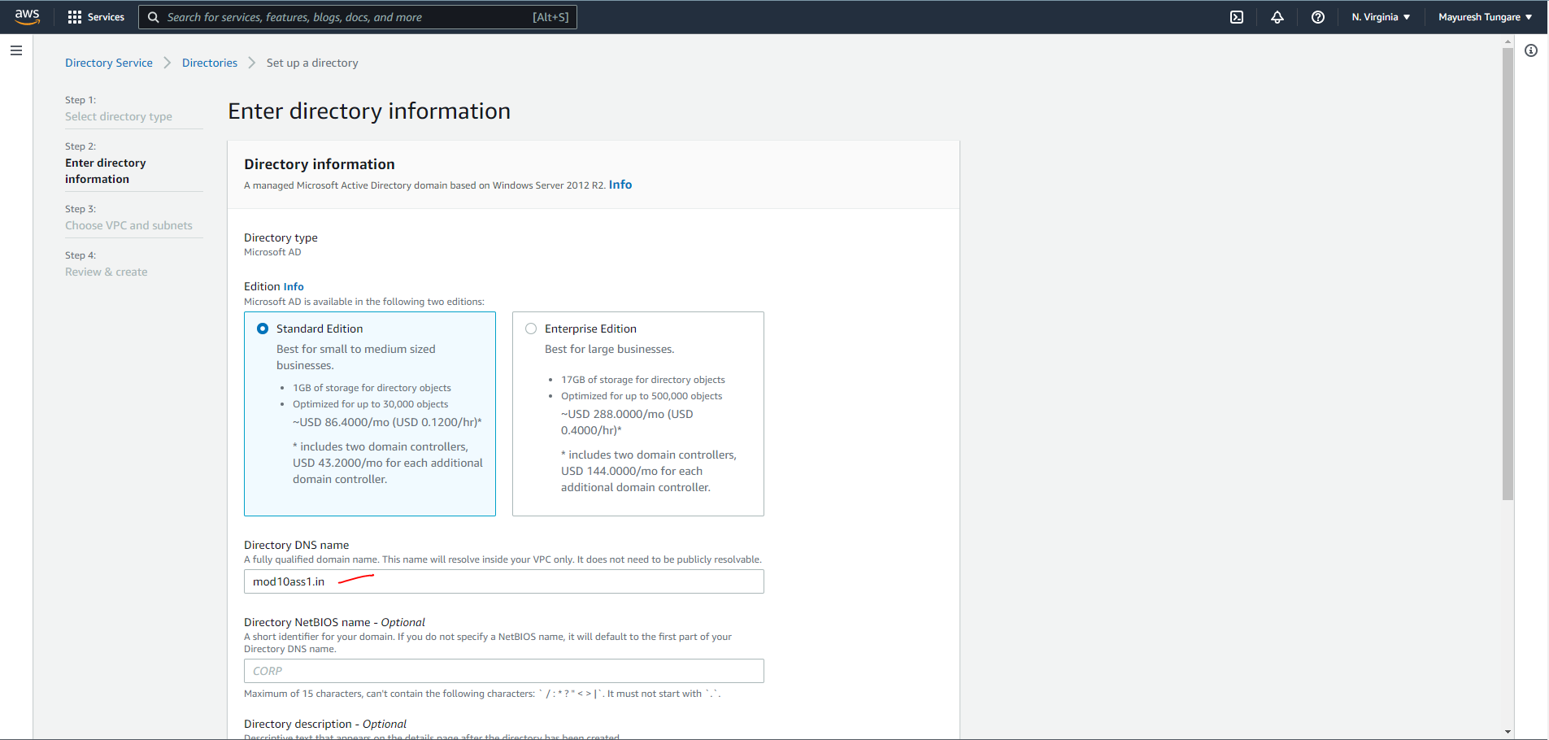

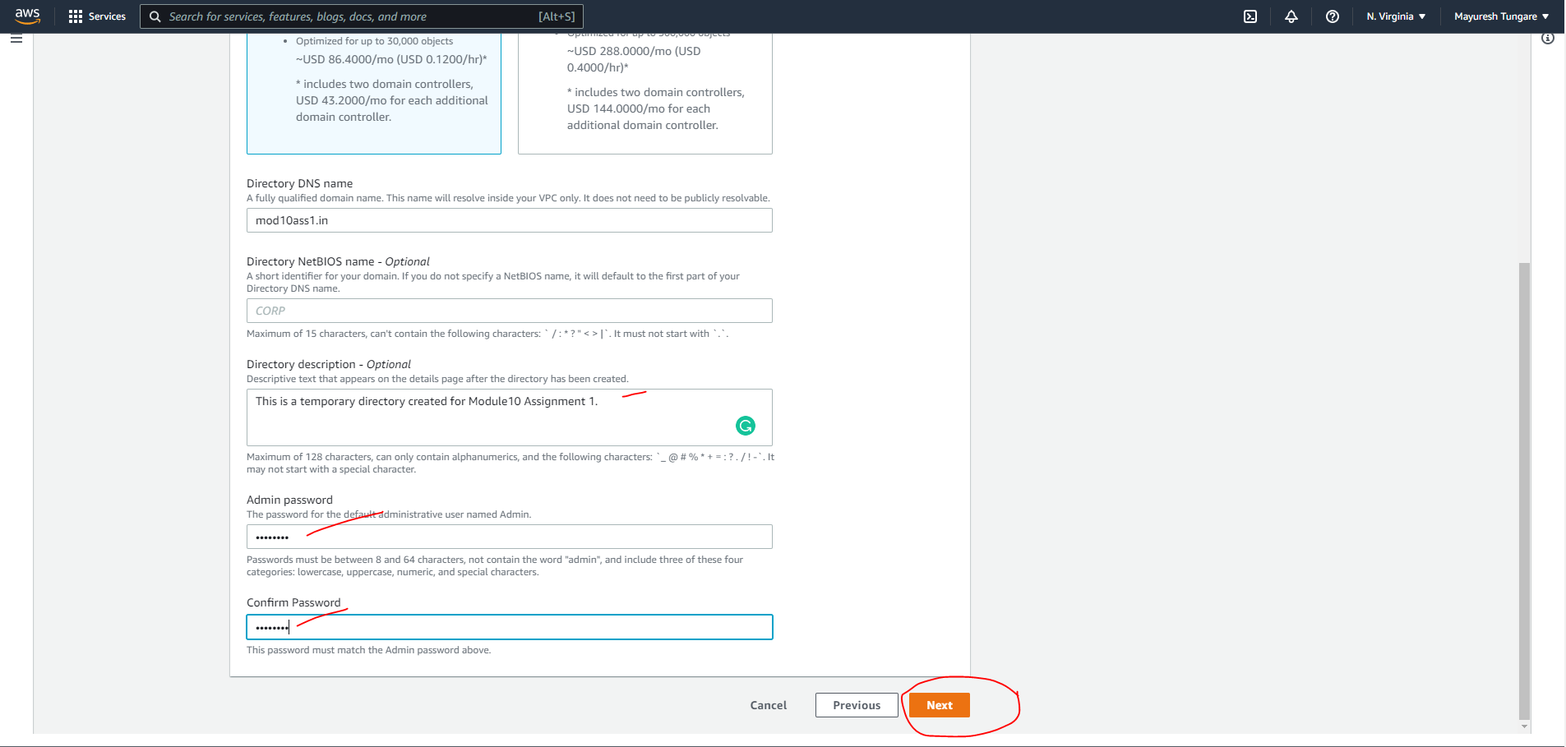

1. On next screen, we enter details as below:

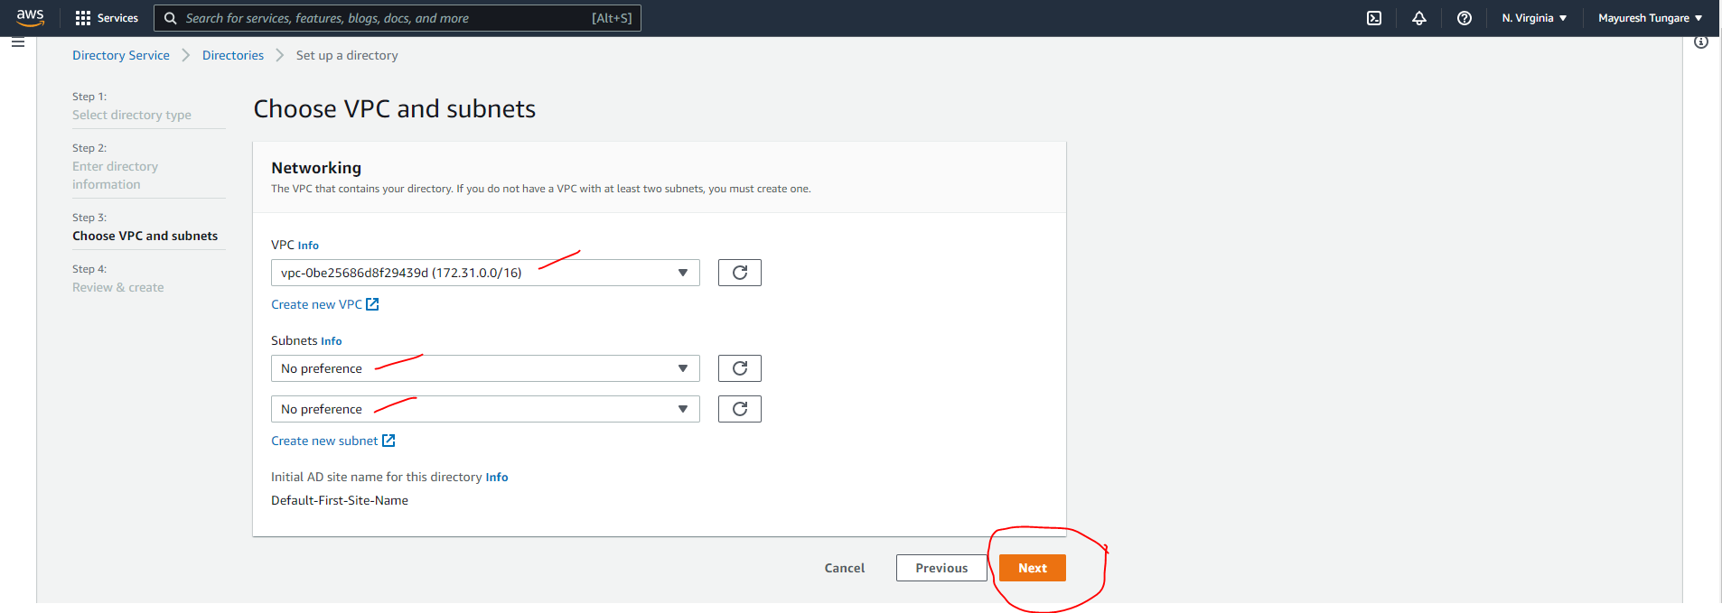

1. On next screen, we confirm details as below and create AD:

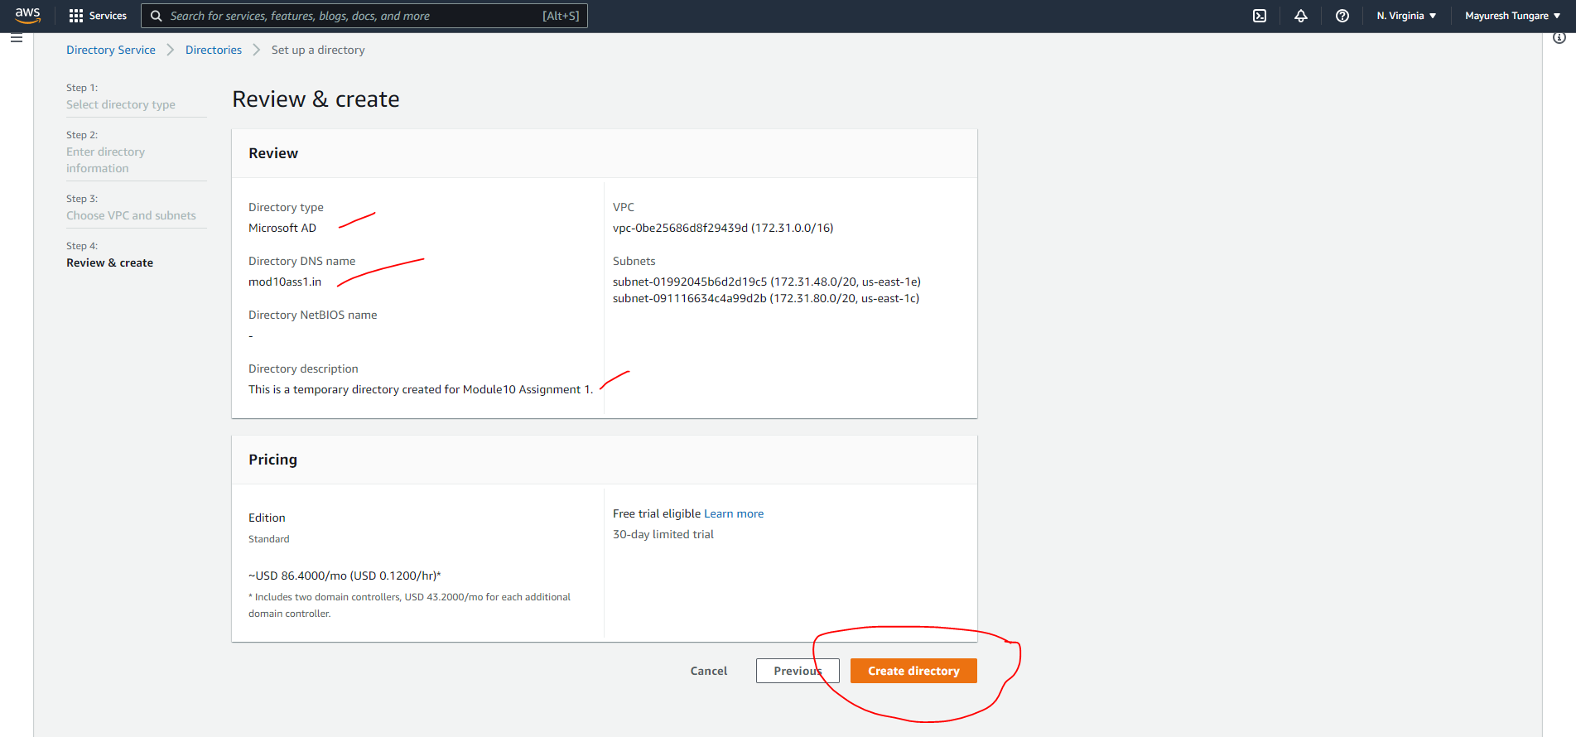

1. We then see the AD is created as shown below:

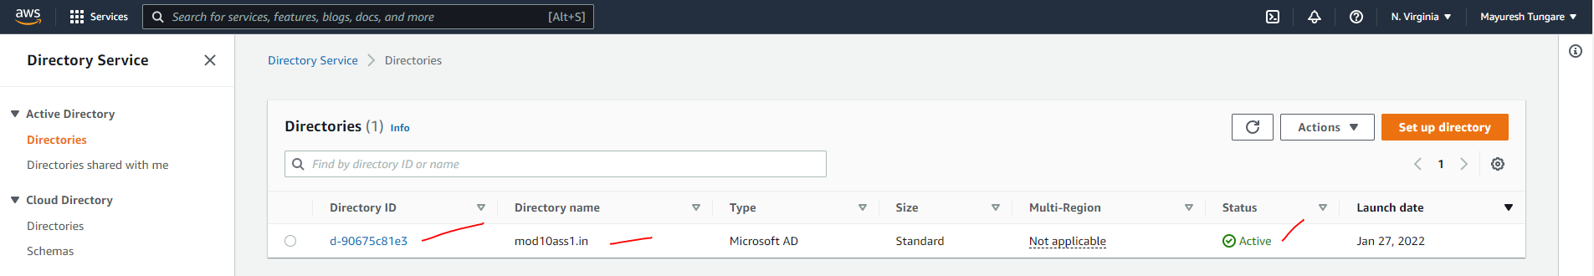

1. Next, we create Amazon FSx for Windows File Server

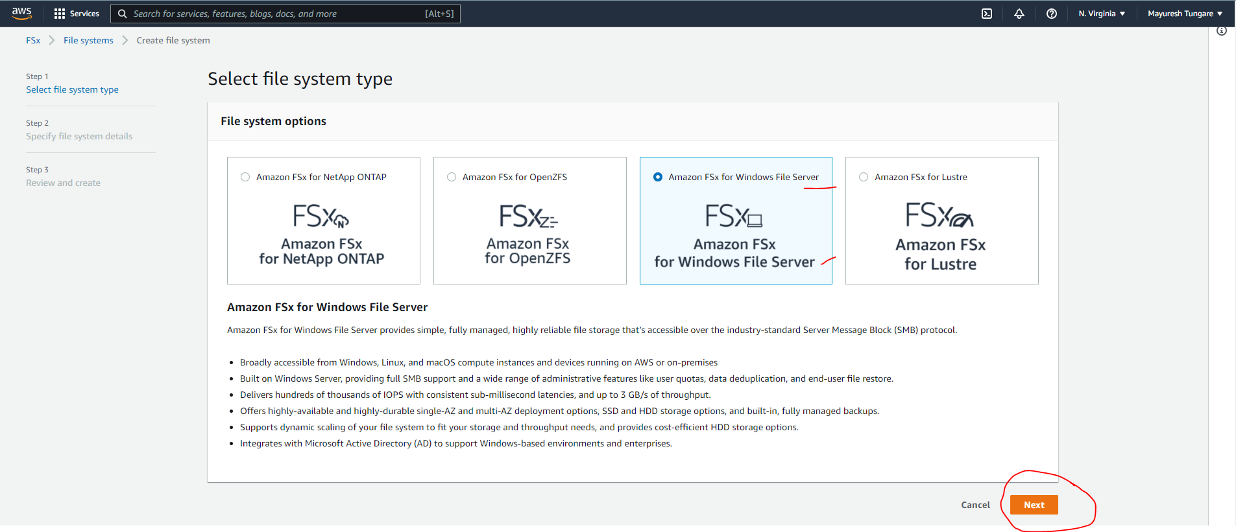

1. We enter details as shown below and link to Active Directory (refer step 6)

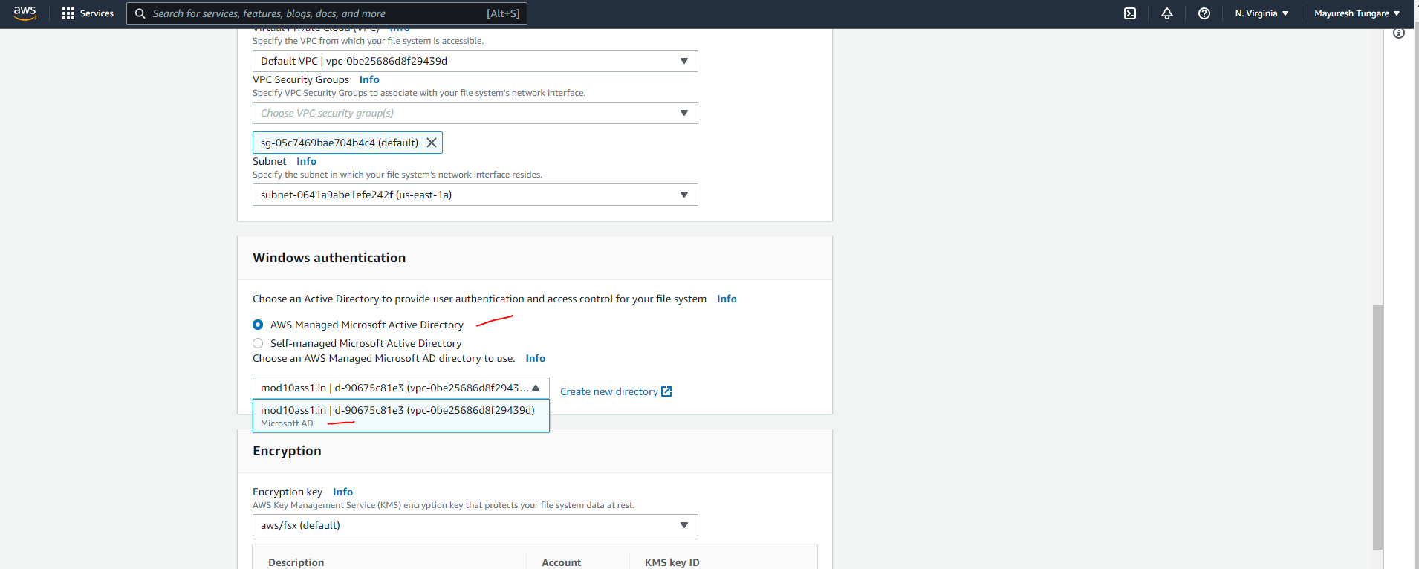

1. We see that FSx file system has been created:

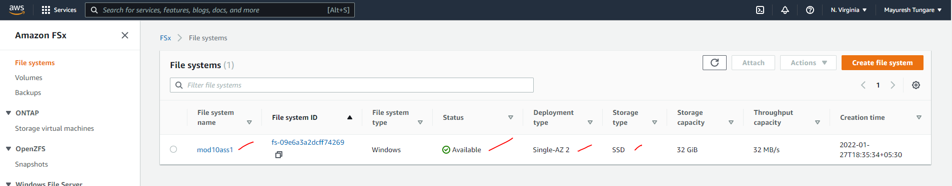

1. Next, we launch a Windows EC2 instance

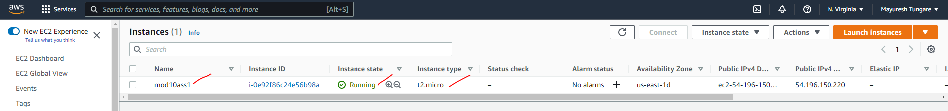

1. Next we connect to the server using RDP connection and add the Windows FSx

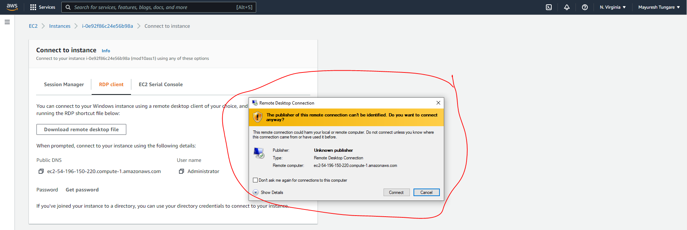

1. Now we move on to the second part of this assignment. That is, we need to create an FSx file system for Lustre and attach it to an Amazon Linux 2 instance.
2. For this, we first create an EC2 instance. We head to EC2 dashboard and launch an Amazon Linux EC2 instance named ‘mod10ass1’ as shown below.

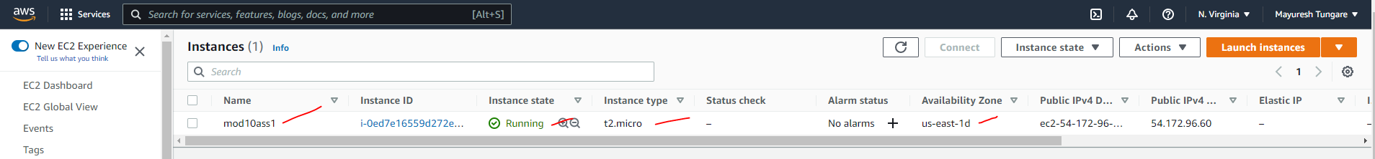

1. For the EC2 instance to connect to FSx filesystem for Lustre, we need to create an inbound rule in default security group which allows traffic from port 988 as shown below:



1. Next, we go to create FSx filesystem for Lustre – we head to FSx service

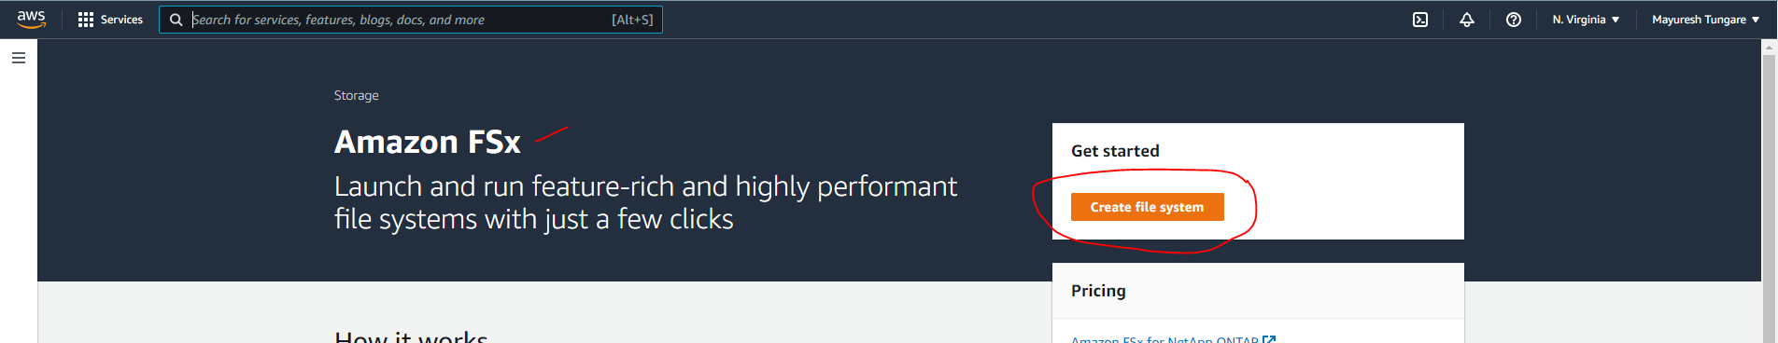

1. On next screen, we choose option Amazon FSx for Lustre

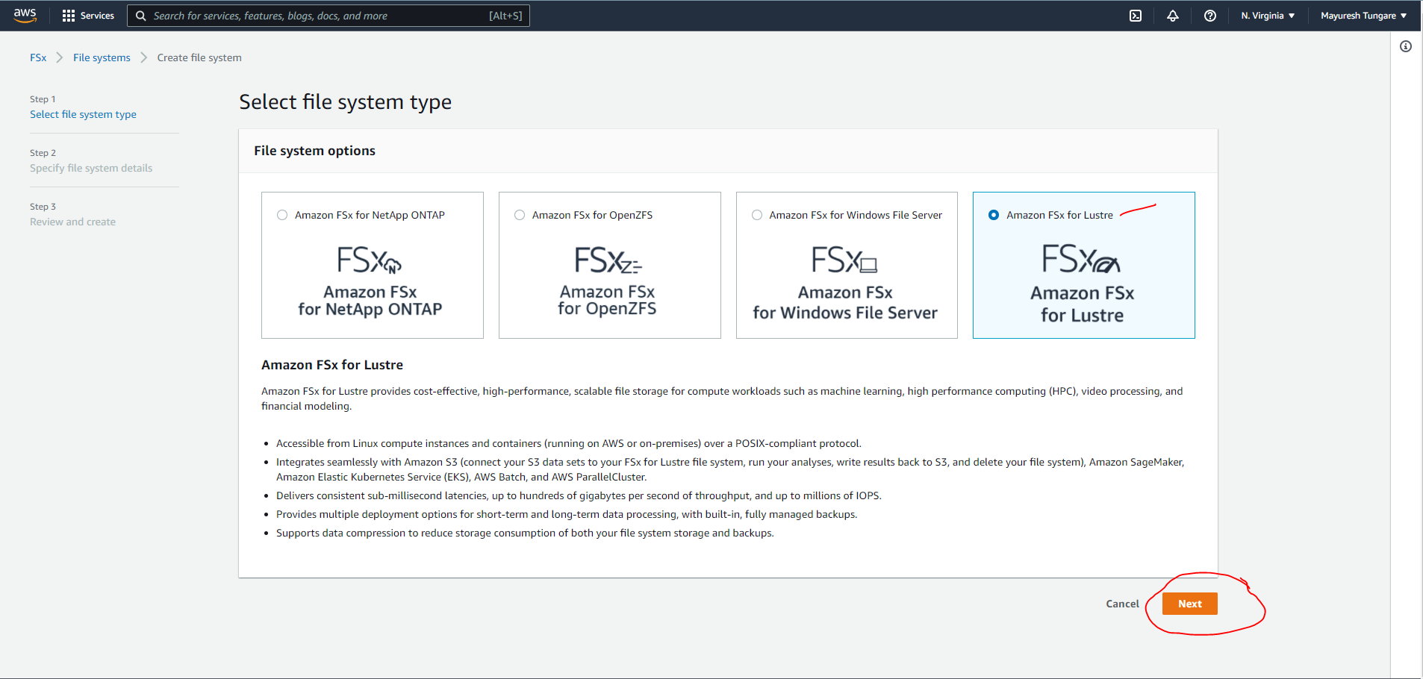

1. Next we enter the parameters as shown below and click on ‘Create Filesystem’:

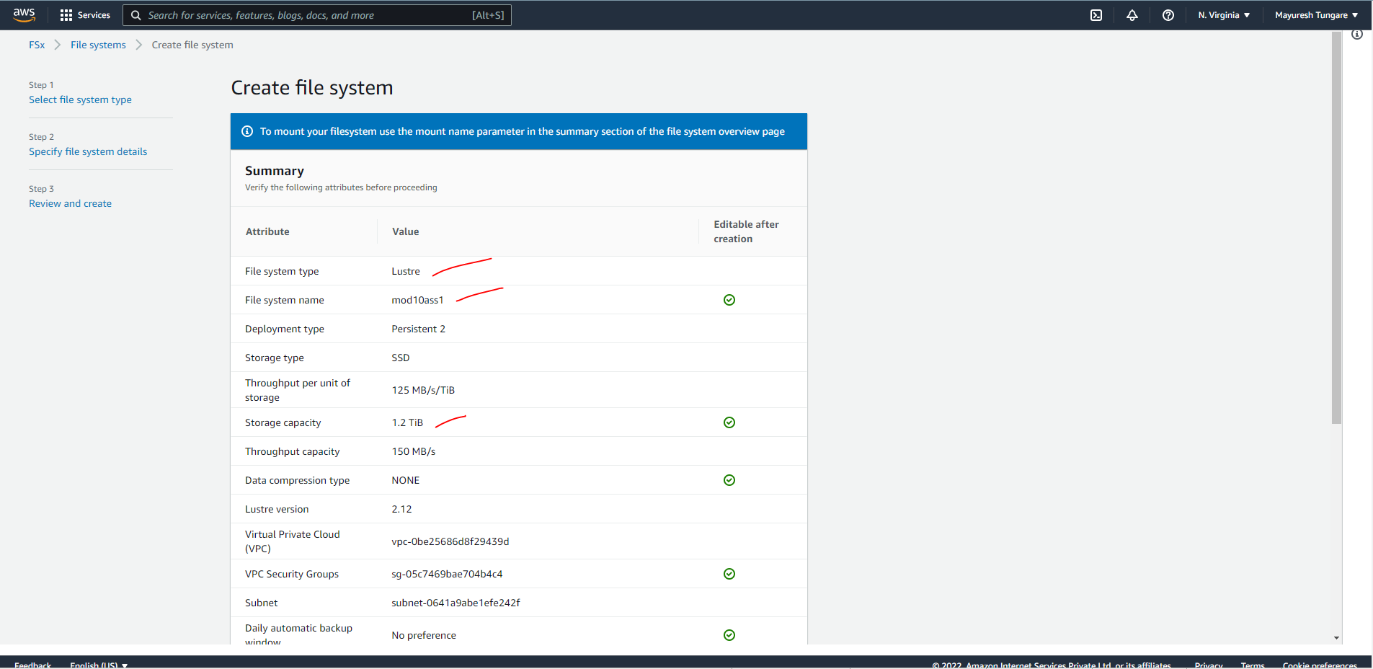

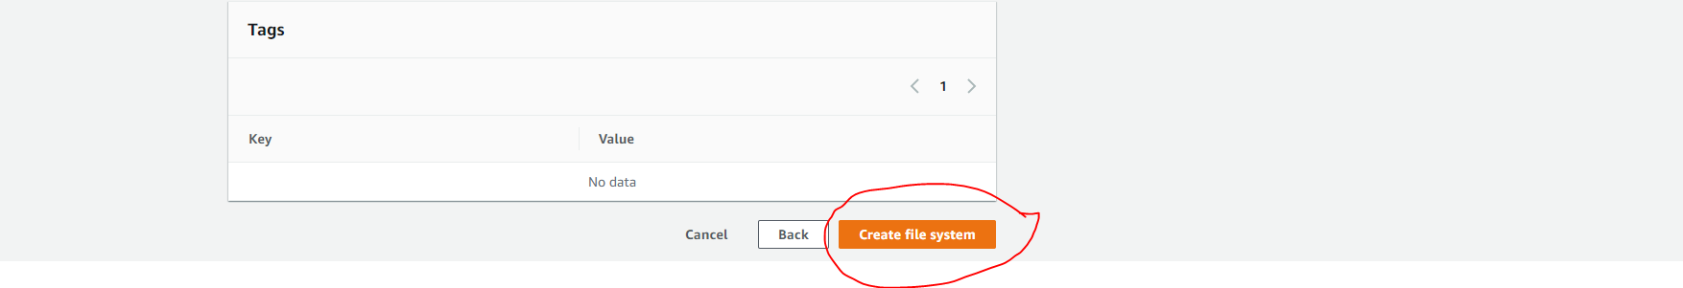

1. We can then see that the FSx filesystem has been created as shown below:

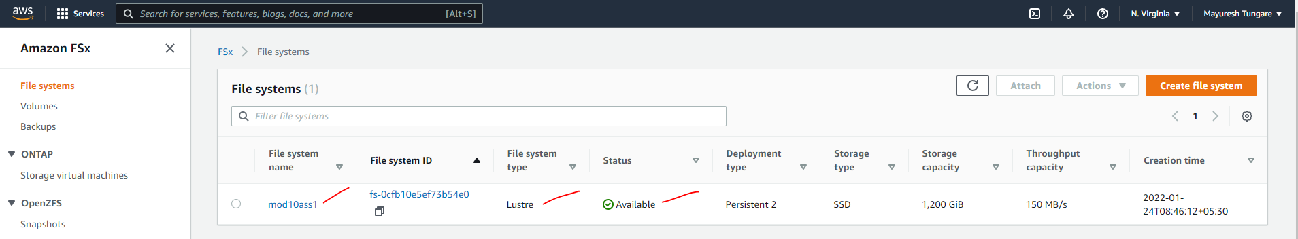

1. Next, we SSH into the EC2 instance we created in step 13.

Command: **ssh -i nginxwebserver.pem ec2-user@54.172.96.60**

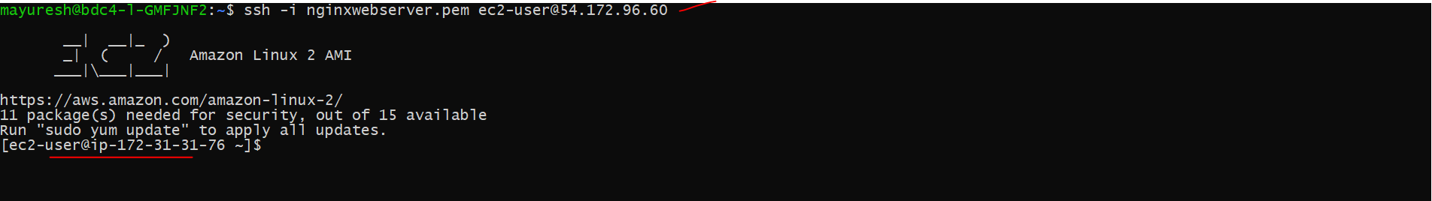

1. Next, we install Amazon Linux Extras can be installed using below command

Command: sudo amazon-linux-extras install -y lustre2.10

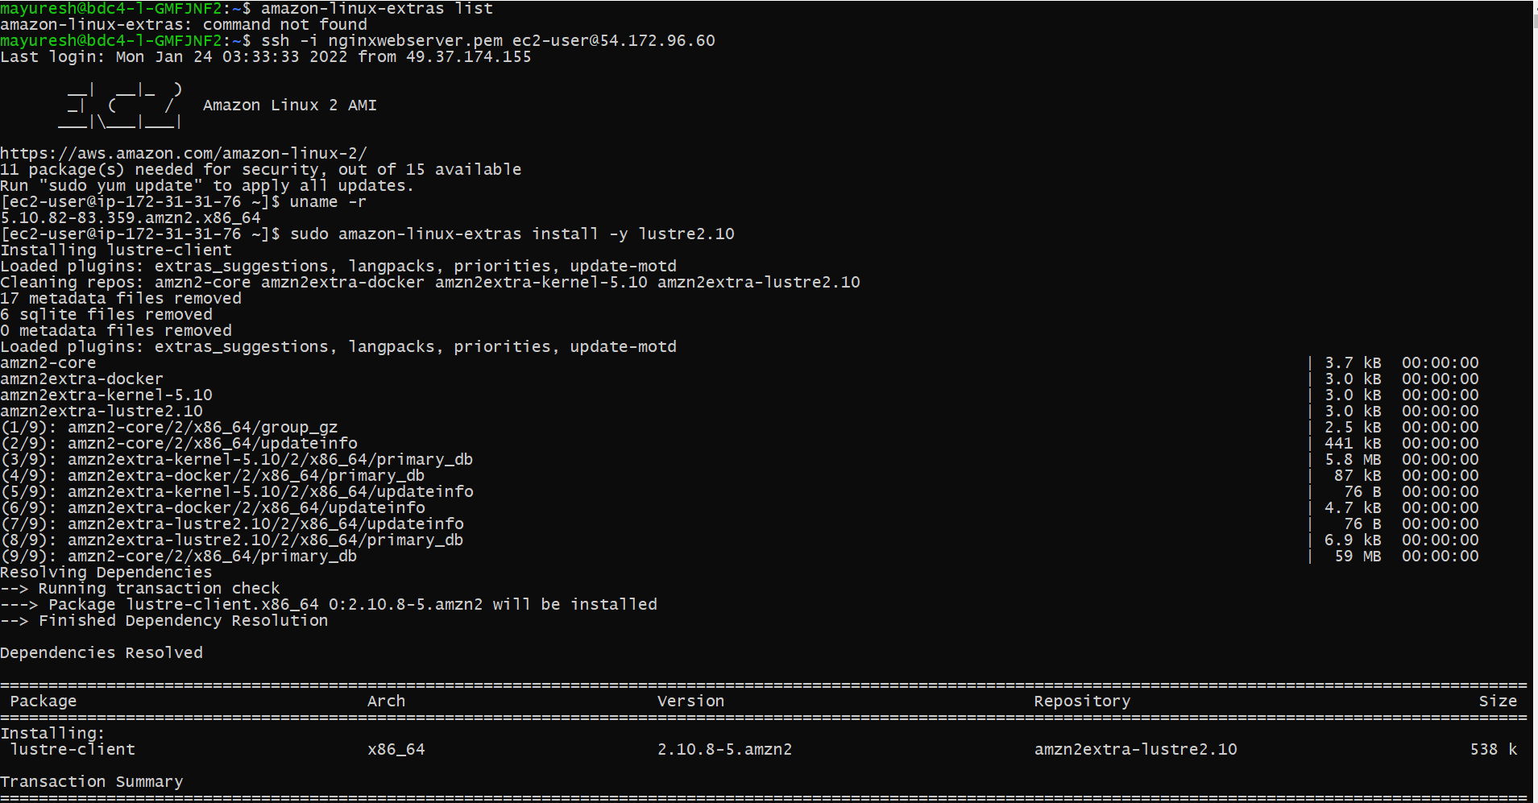

1. Next, we create a directory for the mountpoint as shown below:



1. Next, For that we get the mountname from console.

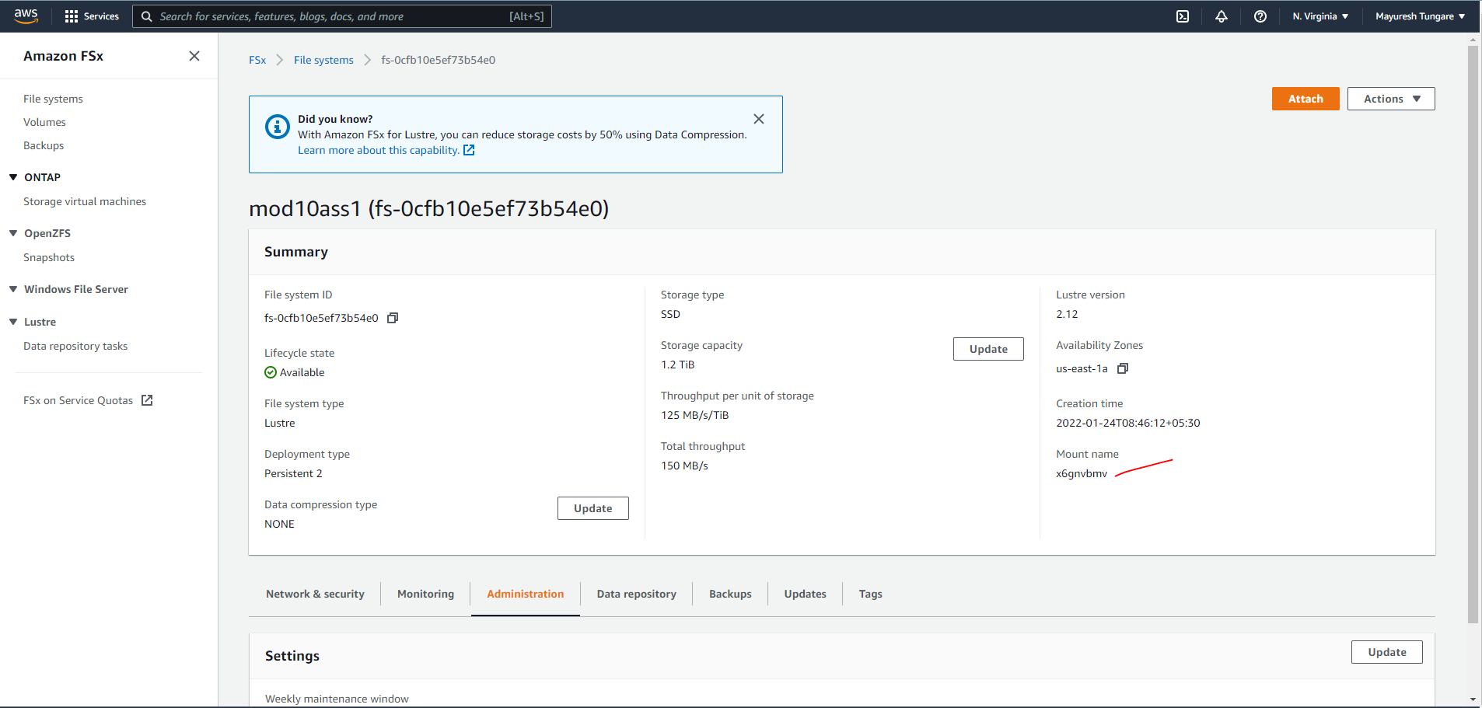

1. Next, we mount Amazon FSx for Lustre as shown below



1. Next, we can also confirm the filesystem has been mounted using dh command

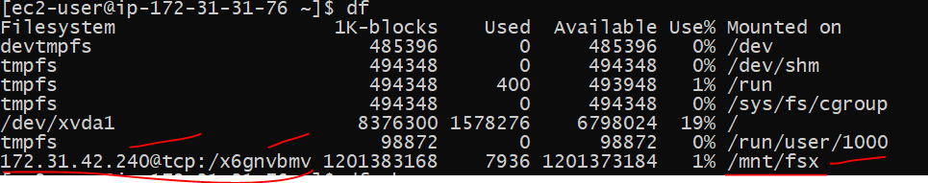

1. Thus this assignment is now complete.